*React is inside client directory And API is inside api directory.
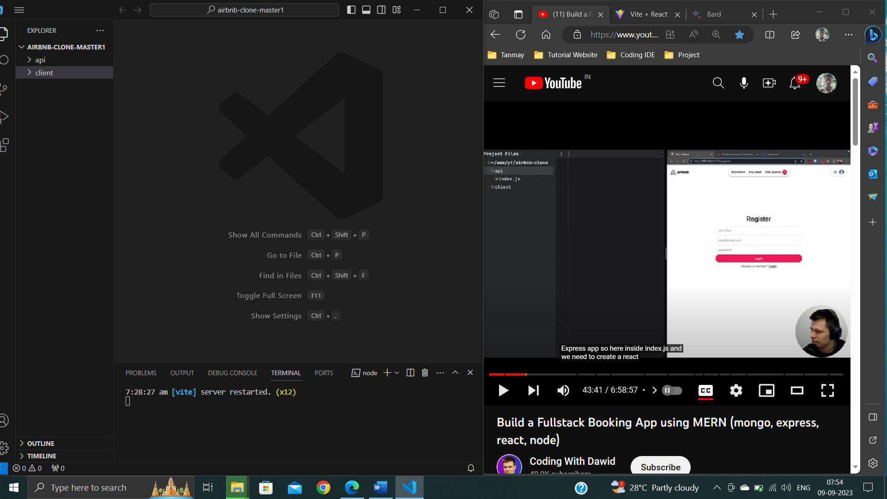
//Creating Template or layout for login and other page
Instead of putting a header again into our login page and then we will need all need footer so both header and footer login page and other component and other pages, we will actually create a template or layout.
Create Layout.jsx file under src directory.
Layout.jsx
import { Outlet } from "react-router-dom";
import Header from "./Header";

export default function Layout()
{
return(
<div>
<Header/>
<Outlet/>
</div>
)
}

//Why Outlet is used?
We want to have content of our page so for index it will be like some random places here for login page it will this login form and so to make it work for our layout we will use a component called Outlet (impoted from react-router-dom).

**DO NOT USE THIS INDENTAION
export default function Layout()
{
Return
(
)
}

**Right way INDENTAION
export default function Layout()
{
Return(

)
}

//ERRO
import Header from "./Header";

Already included file name 'g:/Our Project/airbnb-clone-master1/client/src/Header.jsx' differs from file name 'g:/Our Project/airbnb-clone-master1/client/src/header.jsx' only in casing.
The file is in the program because:
Imported via "./Header" from file 'g:/Our Project/airbnb-clone-master1/client/src/Layout.jsx'
Root file specified for compilationts(1261)
module "g:/Our Project/airbnb-clone-master1/client/src/Header"

The error message is saying that the React compiler has found two files named Header.jsx and header.jsx, and they differ only in casing. The compiler cannot import both files, so it is giving you an error.
The file Header.jsx is in the program because it is imported by the file Layout.jsx. The import statement uses the relative path ./Header, which means to import the file from the current directory.
The root file for compilation is Layout.jsx, so the compiler will only look for imports in that file and its subdirectories. This is why the file header.jsx is not being imported.
To fix this error, you need to rename one of the files so that they do not have the same name. You can either rename Header.jsx to header.jsx or rename header.jsx to Header.jsx.
However, I noticed that the file Header.jsx is imported in the file Layout.jsx. This means that you are trying to import the file Header.jsx as a React component. React components must be named in PascalCase, so you should rename the file header.jsx to Header.jsx.
Once you have renamed the file, the error should go away.
Here are some additional things to keep in mind about file casing in React:
- The names of React components must be PascalCase.
- The names of variables and functions can be either PascalCase or camelCase.
- The names of files can be either PascalCase or lowercase.
It is generally recommended to use PascalCase for the names of React components and camelCase for the names of variables and functions. This will help to make your code more readable and consistent.
//With the content of App.css file.
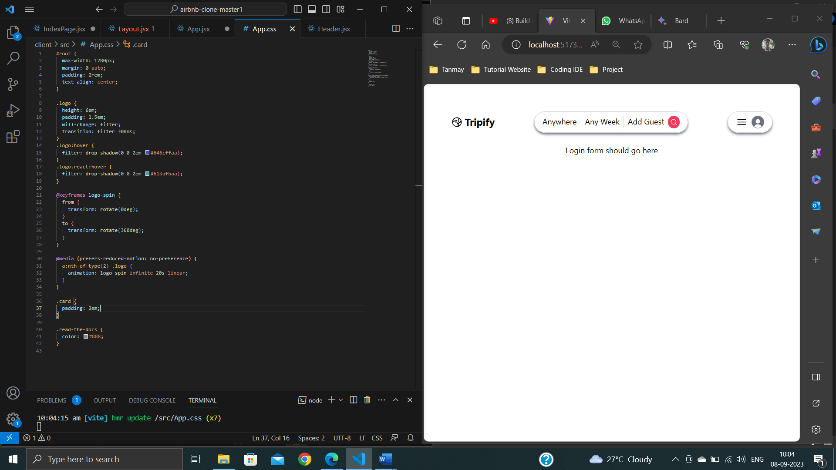

\\ Without the content of App.css file
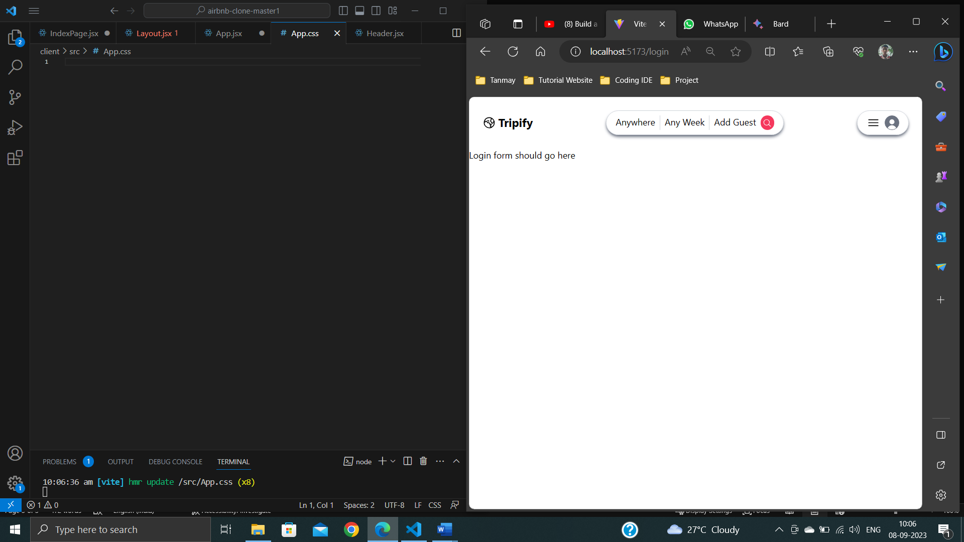

API endpoint:
An API endpoint is a specific location within an API that accepts requests and sends back responses. It's a way for different systems and applications to communicate with each other, by sending and receiving information and instructions via the endpoint. Here are some of the different types of API endpoints: GET, POST, PUT, DELETE.
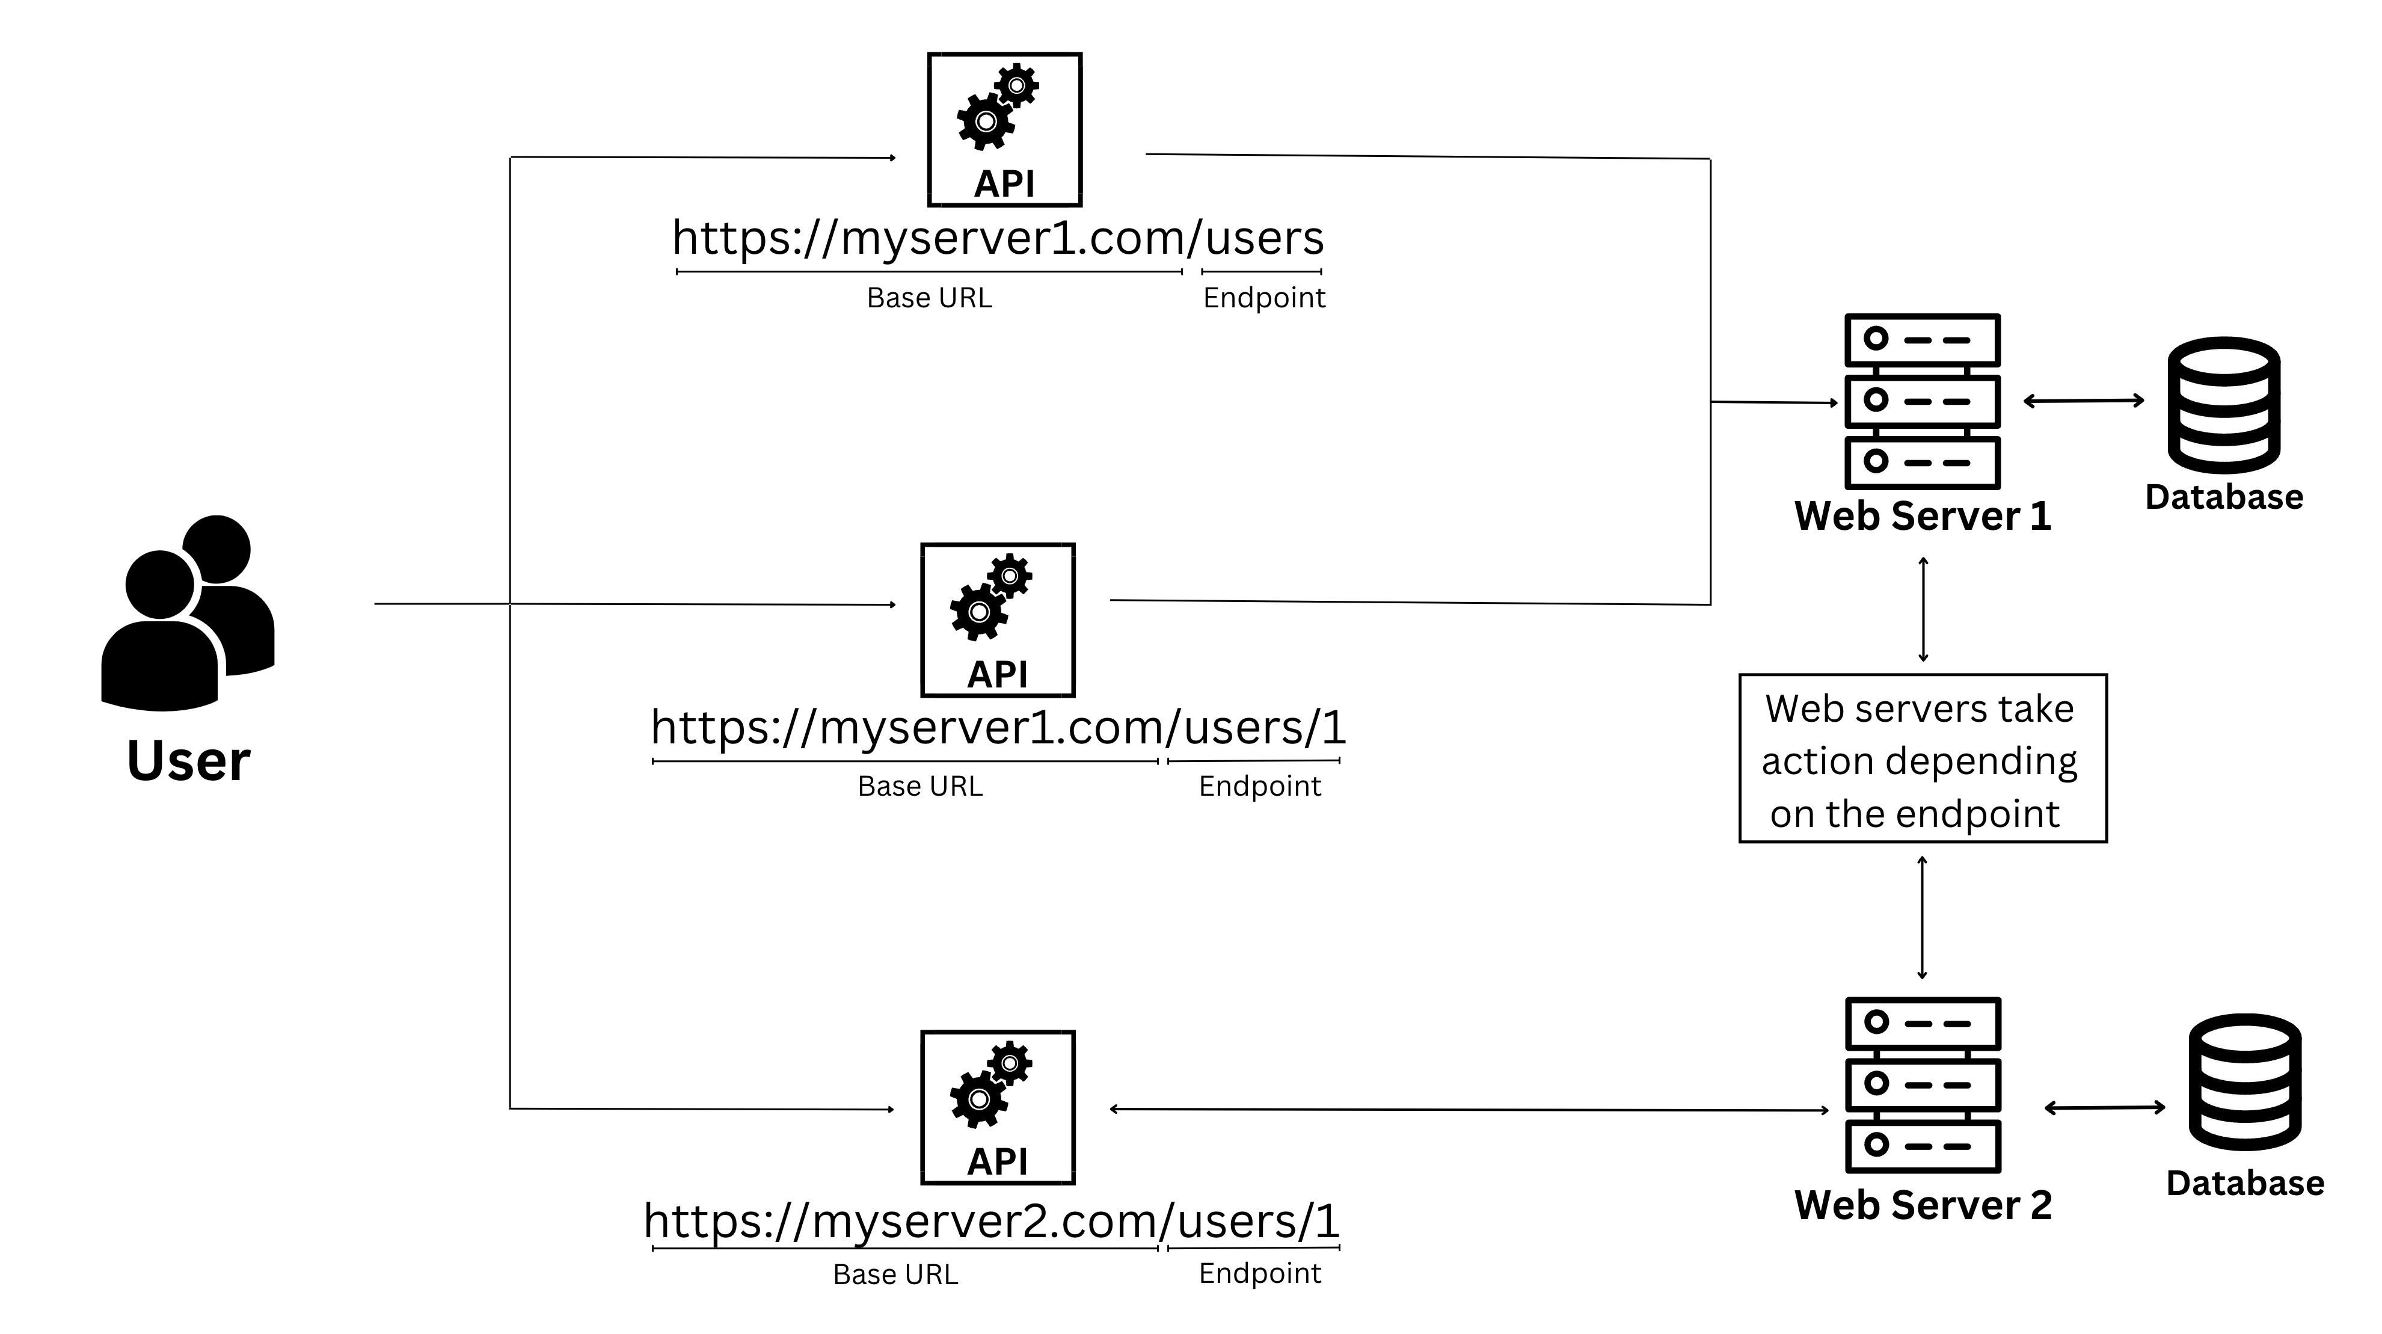

The commands npm install cors and npm install course are not the same. The first command installs the cors module, which is a Node.js module that allows cross-origin resource sharing (CORS). The second command installs the course module, which is a Node.js module that provides a course management system.
If you are trying to fix the error message "Cannot find module 'cors'", then you need to run the command npm install cors. If you are trying to install a course management system, then you need to run the command npm install course.
